# Comp3000 final year project GDD

Comp3000 final year project GDD 1

Problem Domain 2

Study of similar products on the market 3

Gris 3

Night in the Woods 4

Headspace 5

CBT Companion 5

Summary 6

Project Description 7

Characters 7

Player character 8

NPCs 8

Story 9

Setting 9

The Map 10

Theme 10

Story Progression 10

Game Opening 11

The main game 11

Ending 11

Goals 12

Short Term Goals 12

Long Term Goals 12

Game Mechanics 13

Items and Power Ups 13

Progression and Challenge 13

Losing 13

Art Style 13

Overall 13

Characters 14

Environment 14

User Interface 14

Music and Sounds 14

Technical Description 15

Marketing 15

Platforms and Monetisation 15

Localisation 16

Accessibility 16

Other Ideas 17

# Problem Domain

Many people would benefit from learning healthy habits and practices that improve their wellbeing, but people aren't given the opportunity to learn these skills until they reach a crisis point and need to seek help. It can be overwhelming and time consuming to start looking into psychology and mental health maintenance as an individual, which may dissuade people from making it a priority in their life.

Media can be a powerful tool to influence audiences priorities, interests, and opinions. Games as a medium can be a very successful educational tool, teaching people through play. Both games and media as a whole are likely to be more appealing to an individual than a self-help section of a bookshop. By researching how media affects audiences, I will make a game which aims to not only provide an enjoyable experience and escapism, but also to inspire better self care practices in users.

Exploring problem domain

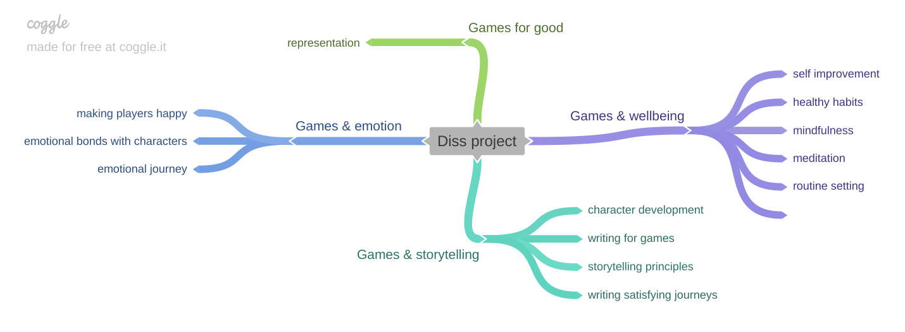

* Narrative game with a focus on wellbeing and learning self care practices.
* Inspired by the wholesome games movement.
* Informed by research about how media can affect audiences to change their own lives.
* Should have basic controls, more accessible to people who aren’t avid gamers.

## Study of similar products on the market

Considering similar games and applications for wellbeing, seeing what makes them successful, and what attributes from them I can take or leave when it comes to my own project. Asking the questions:

What is the product?

How does it aim to help users?

What makes it a good example of this type of product?

What parts of this will I keep?  
How will my game be distinct, offer something new?

#### Gris

|  |  |
| --- | --- |
| What is the product? | **Gris**, a game from indie developer [Nomada Studios](https://nomada.studio/), explores the emotional experience of traversing the trials and tribulations of grief through a beautifully designed, watercolour-style, puzzle platformer. |
| How does it aim to help users? | Gris a character going through grief that they can relate to, offering emotional support and understanding. |
| What makes it a good example of this type of product? | Gris communicates a complex, emotive story with symbolism rather than dialogue.  It’s been received well by audiences, selling over a million copies and winning multiple awards.  The approach to grief is informed by psychologists, especially the concept of the 5 stages of grief. |
| What parts of this will I keep? | I will also create story progression and goals inspired by psychology and informed by research.  I’ll look into how I can enhance my story with visuals, especially how game mechanics and colour are utilised. |
| How will my product be different? | My game will have multiple characters to interact with, so more of the storytelling will be done through dialogue.  Rather than capturing one specific experience, like Gris does with grief, my project will focus on general feelings of anxiety and depression. |

#### Night in the Woods

|  |  |
| --- | --- |
| What is the product? | **Night in the Woods** is an adventure game focused on exploration, story, and character, featuring dozens of characters to meet and lots to do across a lush, vibrant world. The themes addressed include mental illness, depression, the stagnancy of the middle and lower classes, and the slow death of small town America. |
| How does it aim to help users? | The main purpose of this game is entertainment - it shows a character struggling with some mental health issues, but it is not the main purpose of the game or the reason to play it. People choose to play it to have fun, and while they’re at it, may feel comforted and seen by the depictions of depression. |
| What makes it a good example of this type of product? | It depicts mental health accurately, as something that multiple characters deal with but which doesn’t define them. Minigames offer a break in the stress and dark world for both the main character and the player. The story and the main characters' experience is affected by who players choose to interact with more. There’s no right or wrong way to play. |
| What parts of this will I keep? | Character driven. Player choices influence the story without changing the overall direction of the game. |
| How will my product be different? | My product will be a slightly more hopeful take - rather than simply normalising and representing mental illness, I’ll focus on showing different coping mechanisms and representing characters grow and improve their wellbeing. |

#### Headspace

|  |  |
| --- | --- |
| What is the product? | **Headspace** provides [guided meditation](https://en.wikipedia.org/wiki/Guided_meditation) resources online, accessible to users through the company's website and via a mobile app on the iPhone and Android platforms. |
| How does it aim to help users? | Headspace teaches mindfulness to help cope improve mental health and wellbeing. |
| What makes it a good example of this type of product? | It’s proven to be effective - studies have found a significant increase in wellbeing, reductions in anxiety and depressive symptoms, significant reductions in diastolic blood pressures, significant increases in perceived job control, as well as a significant reduction in sleeping problems. |
| What parts of this will I keep? | Informed by science and psychology, easy to dip in and out of for short periods of time. |
| How will my product be different? | My product will provide entertainment as well as support, and aim to teach good habits which can be used outside of the product. |

#### CBT Companion

|  |  |
| --- | --- |
| What is the product? | **CBT Companion** is a companion app to learn and practise Cognitive Behavior Therapy (CBT) Techniques. |
| How does it aim to help users? | Teach users CBT and provide an environment for them to practise it in. |
| What makes it a good example of this type of product? | Focused on one specific approach to treating mental illness. Makes a proven form of therapy, CBT, more readily available and accessible to users so they don’t have to wait until they hit a crisis point to be referred to a therapist. |
| What parts of this will I keep? | I will include CBT methodologies as one of the techniques showcased in my game. I especially like the idea of teaching a specific approach, using the product as a way to teach and practise those skills, and then have users take away what they learnt into daily life outside of the product. |
| How will my product be different? | My game will provide multiple different approaches to mental health informed by therapy, and use gamification to help enforce lessons and make it more appealing to learn. It’ll appeal to a wider audience of people who casually want to improve their wellbeing without taking time out specifically to learn therapeutic techniques. |

#### Summary

|  |  |  |
| --- | --- | --- |
| Name | Image | Key takeaways for my project |
| Gris |  | * Visual storytelling * Informed by psychological theory * Hopeful |
| Night in the Woods |  | * Dialogue based storytelling * Entertainment first * Simple gameplay |
| Headspace |  | * Informed by psychological theory * Easy to pick up and put down |
| CBT Companion |  | * Informed by a specific treatment approach * Will include CBT methods as one of the options |

# Project Description

A small, character driven game set in a small village. Play is based around helping people in the town be happier. Each character requires a different type of task to help them out, each inspired by a different form of self-care or therapeutic practice. By helping others, the player character themselves benefits and builds themselves a better, more fulfilled, life.

Points to refer to:

* Calming escapism at the end of the day
* Informed by psychological practices
* Playable in short sessions

# Characters

*Characters before story (define key players)*

*This could have sections for side characters/main characters*

*Artwork here*

Character creation template:

|  |  |
| --- | --- |
| Name |  |
| Character Archetype |  |
| Personality |  |
| Their problem |  |
| How to help them |  |
| Personality |  |
| Appearance/  Inspiration |  |
| Notes |  |

## Player character

|  |  |
| --- | --- |
| Name | Turnip |
| Personality | Quiet, closed off, shy |
| Goals | Wants to settle into their new home and improve their life through connecting with the environment and the village inhabitants. |
| Appearance/  Inspiration |  |
| Notes | * Blank slate for players to connect with * Newcomer to the village |

## NPCs

|  |  |
| --- | --- |
| Name |  |
| Character Archetype |  |
| Personality |  |
| Their problem |  |
| How to help them |  |
| Personality |  |
| Appearance/  Inspiration |  |
| Notes |  |

# Story

Start - disconnected little town, everyone keeps to themselves and isn’t happy

Middle - player starts helping people out

End - People are happier, player has a little party with people from town

# Setting

Small village/town in the British countryside.

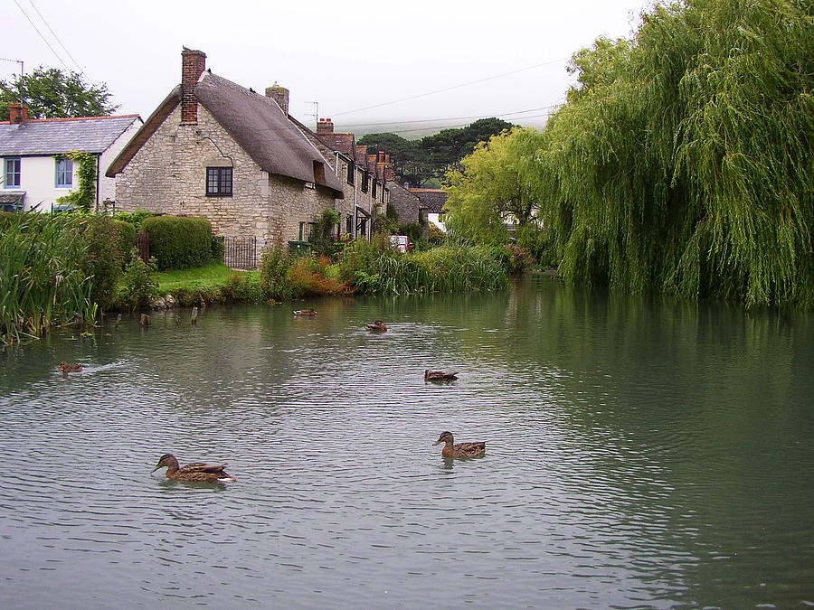

Real life inspiration - LLandidloes, Sutton Poyntz, Hurstpierpoint.

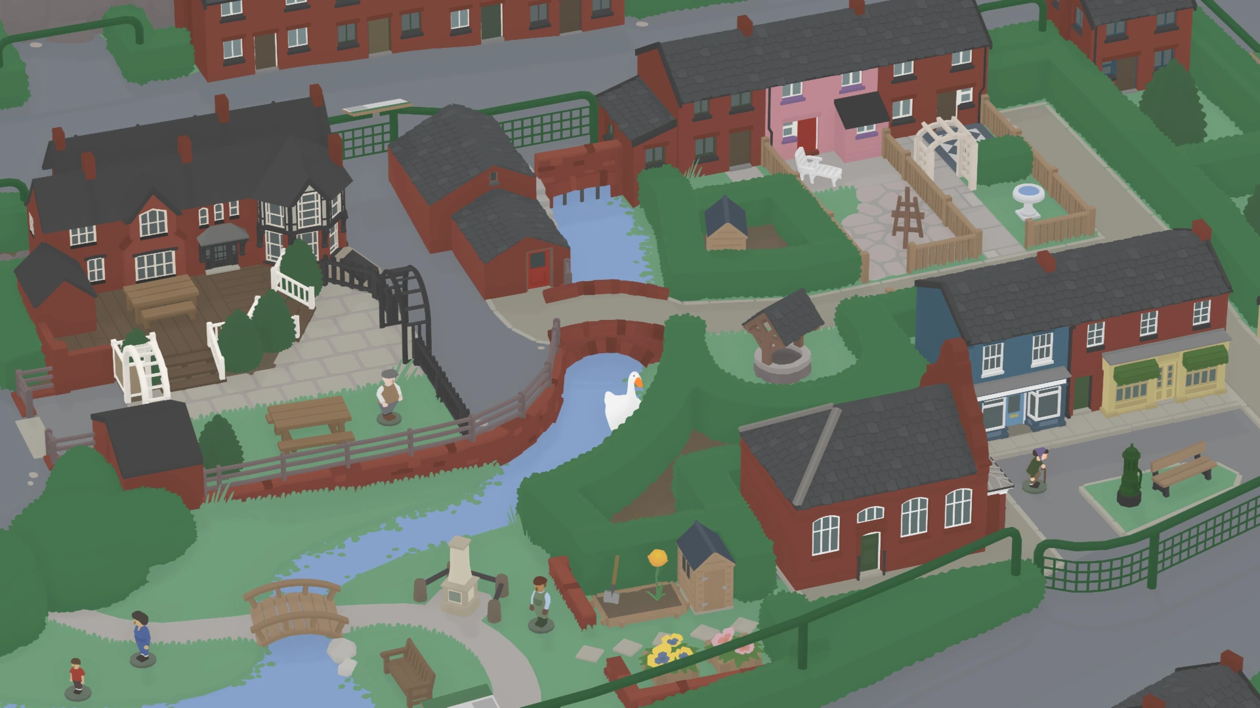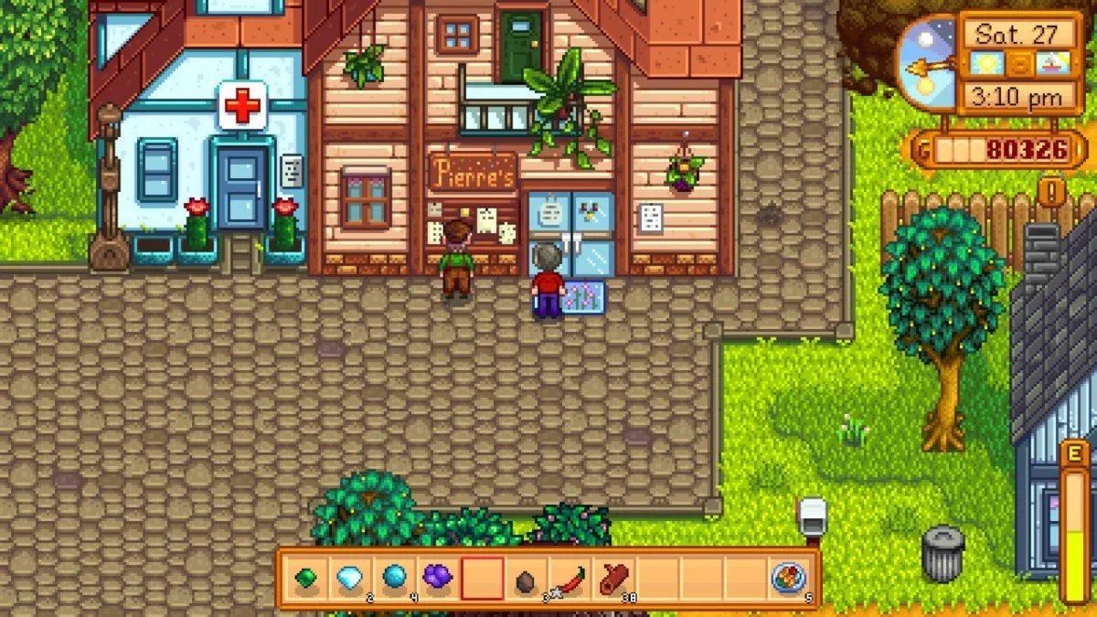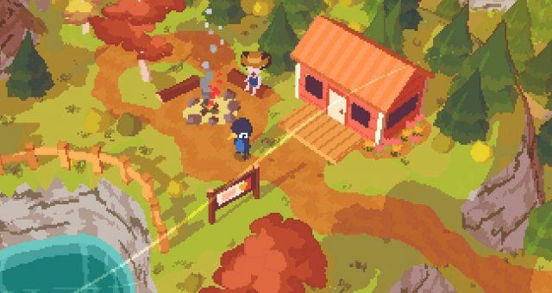

Game inspiration - Untitled Goose Game, Stardew Valley, A Short Hike.

Key points:

* Rural, countryside setting.
* Surrounded by nature - autumn.
* Selection of small independent shops required for the community to thrive.
* Central hub around duck pond with key shops, then houses and other businesses spread out into the surrounding country.

# The Map

# Theme

The main theme of the story is this: different self care practices help different people. Helping others helps you help yourself.

# Story Progression

*How does the story represent itself in changes with the game*

*This can discuss zones in relation to story beats*

*Eg first area is tutorial, x story beat is introduced x character is met*

*How does the story change as the player progresses through the game*

*What different areas are unlocked and in what order*

The player character has a diary which updates at certain milestones. Each entry is a mix of photos and writing which tell the story of the character’s emotional journey as they become more involved in the world.

The story progression of the world is told through subtle changes to the environment and characters, including:

* The town notice board
* The flowers in the village green
* The amount of people out and about in the town
* The behaviours and art of characters

## Game Opening

The game opens on the main character sat on the floor in their new house, surrounded by boxes. The character stands up, and the player can start controlling the movement. The only item that can be interacted with is the diary on top of one of the boxes.

Upon interacting with the diary, a pop up window shows a new journal entry, briefly explaining that the character has just moved and needs to explore. When the pop up is closed, the book is put back onto an empty bookcase in the background, and can be interacted with at any point.

After interacting with the diary, the player can go to the front door and leave out into the town and start exploring.

## The main game

As player explores the village, they meet a number of townspeople they can interact with. The town noticeboard helps nudge them in the right direction and suggest who they could try and find and help next.   
When a player successfully finishes helping a character, the surrounding town and the characters personality changes to reflect this.

Some examples of this could be:

* Helping a young person connect with nature and get outside and fresh air – they start appearing around town gardening and all of the flowers and plants in community areas perk up and flourish.
* Helping an older person reach out to old friends for a coffee and a chat – they are then found in the café, and start adding weekly meetup events like knitting club to the town noticeboard

## Ending

For the MAP version of the game, the game ends when the player has helped all of the chartacters in the village.

For the vertical slice of the game, the game ends when the player successfully helps one character.

In both endings, the final journal entry shows everyone together in the village green having a fair and being happy.

## Goals

### Short Term Goals

* Help others around the town to make them happy

### Long Term Goals

* Learn different ways people cope with life and make themselves happy
* Understand how people rub off on one another
* Build a closer community and have fun together

## Game Mechanics

Gameplay is intended to be explorational and story driven. The game mechanics are simple and should be easy for anyone to pick up and understand. Player actions are tools to help the user connect with and explore the world, and fun comes from this interaction rather than the actions themselves.

The player actions are identified as follows:

* Walk – 8 directional movement across an isometric plane. Controlled by WASD or arrow keys.
* Interact – When within range of a character or object that can be interacted with. Starts an interaction – could be dialogue or changing the state of an object. The interaction automatically ends when it is completed, and doesn’t require any additional input to return to normal gameplay.
* Open/Close diary – check journal for latest updates/character thoughts. Navigate through pages with arrow keys, and select the same button again to close the pop up and return to normal gameplay.

## Screens and user interface

Users navigate through the different screens according to this flow chart.

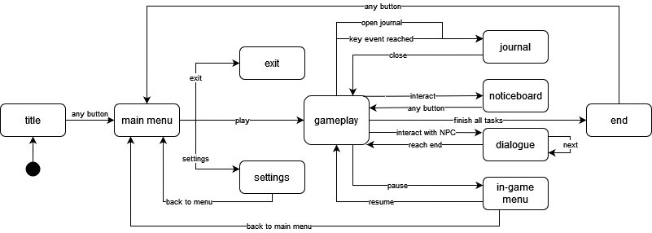

Overall, the screen navigation is simple and straightforward to make the game as accessible as possible.

The only unusual screen is the journal, because users can access it one of two ways – they can manually open the journal screen, but it will also automatically open when a key event that triggers a new journal entry is reached.

# Art Style

### Overall

This section describes the overall art direction of the game.

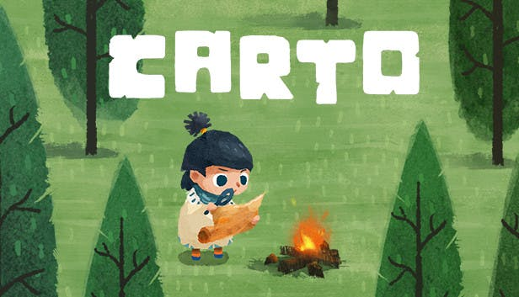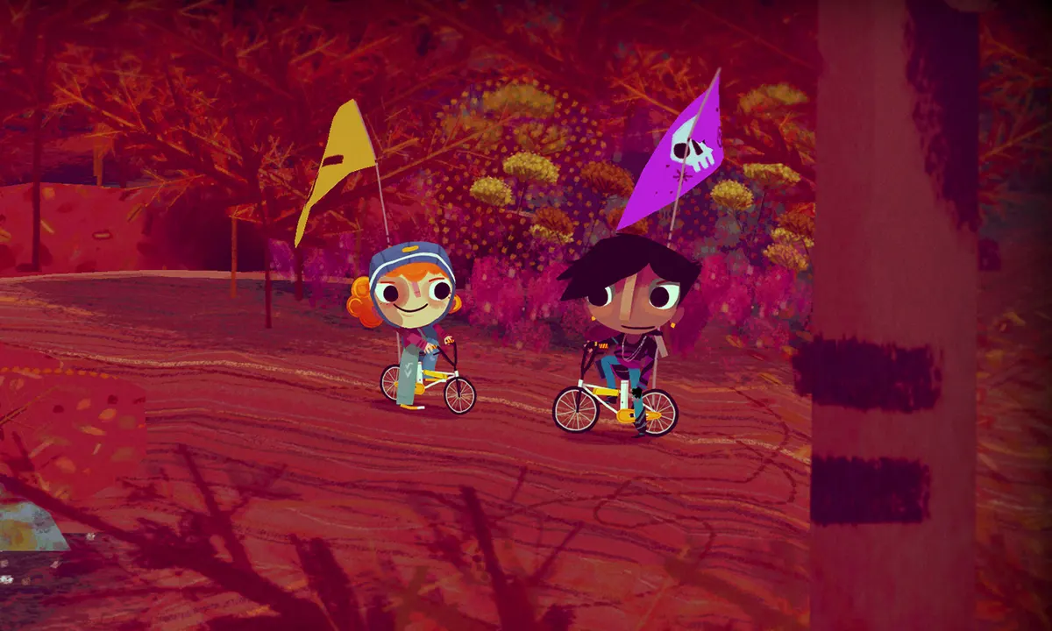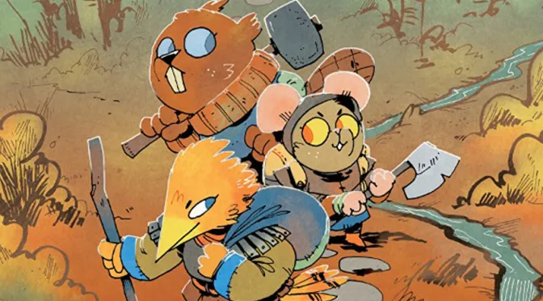

Examples, from left to right: Carto, Knights and Bikes, Root

* Two-dimensional
* Flat, simple shapes but with some painterly textures
* Organic, hand-drawn lines and forms
* Cosy colour palette

### Characters

This section describes the design of the characters in the game.

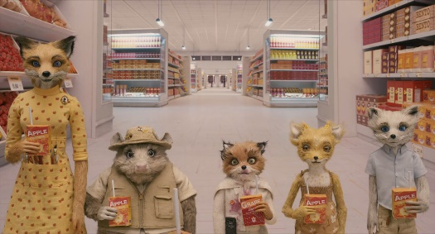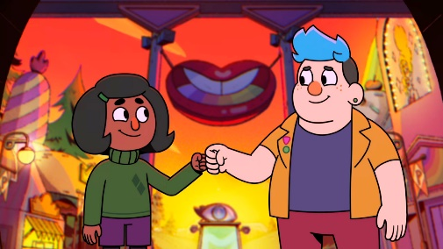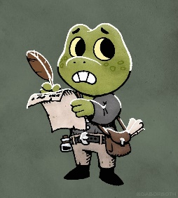

Examples, from left to right: Fantastic Mr Fox, Deadend Paranormal Park, Gábor Both

* Anthropomorphic animals with humanoid bodies and human clothing
* Soft, rounded body shapes
* Squishy, soft, organic forms
* Different line weight for external outlines
* Simple, plain clothing
* Simplified animal faces and characteristics – instantly recognisable, stylised rather than realistic

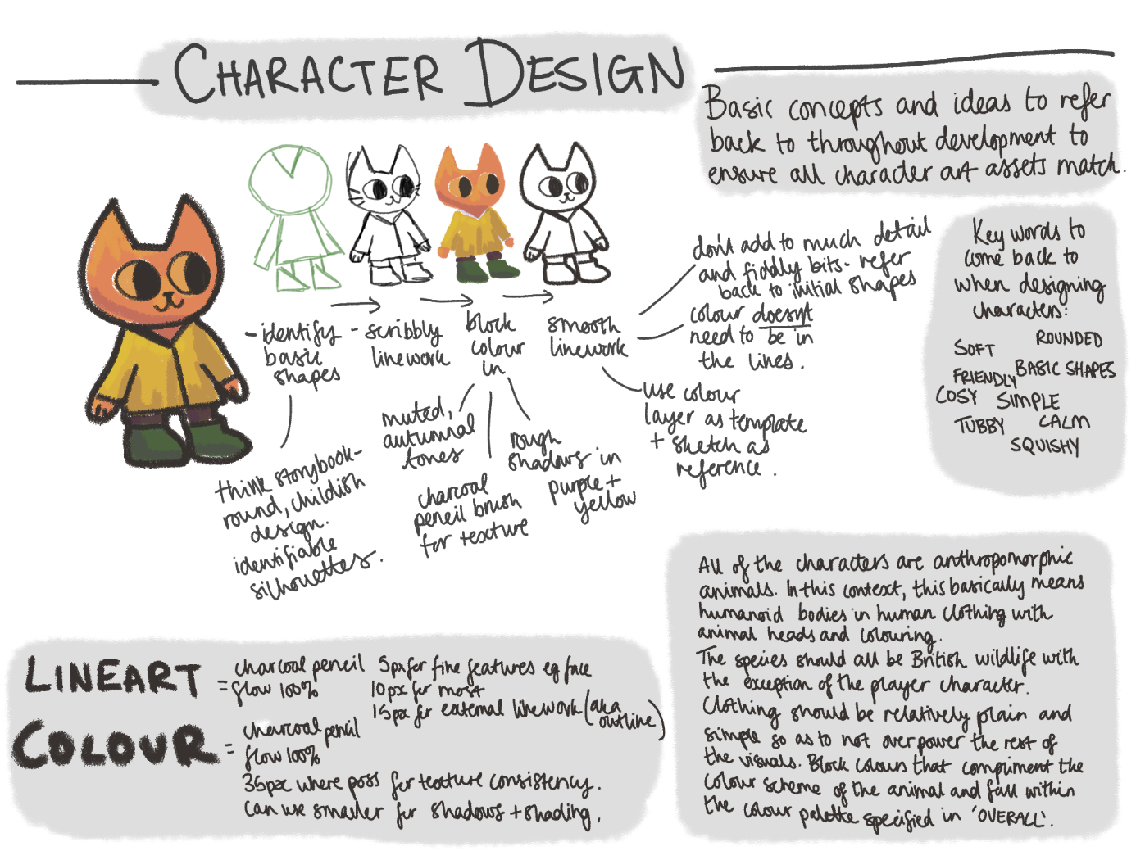

### Environment

This section describes the design of the environment and backgrounds of the game.

Example:

### User Interface

This section describes the art direction of the UI of the game - this includes, windows, icons, and interactive elements. For information about the mechanics and flow of the UI, see the Screens and User Interface section.

# Music and Sounds

Calm instrumentals throughout.

Keywords to describe the music: Acoustic, piano, relaxing, sleep music, calm.

Music is used to depict the mood of characters and narratives in the game but should never be too overwhelming as to take away the feeling of safety and escapism from the player.

The music is soft, gentle, and loops seamlessly to avoid ripping players out of their experience (see the piano instrumentals used in *Minecraft* for reference).

Soft, cartoony sound effects for interactions with other characters, the world, and the UI.

Keywords to describe the sound effects: Soft, whimsical, bouncy, cartoon.

Sound effects are used for each character to reinforce their thoughts and feelings without changing the overall atmosphere. Unique sound effects for each character also help define their characterisation and make them more memorable to the player.

These sound effects aren’t voice lines or dialogue, but rather onomatopoeia (such as hurumph, hmm, woohoo, haha) and nonsense language (see Animalise in the *Animal Crossing* franchise) which communicates personality and tone without being tied to a particular language.

These effects are recorded by a variety of actors and passed through audio editing software to remove background noise and adjust the tone and pitch to make them sound unique.

Sound effects are also used to help root the player in the world and add weight to their actions. Common actions such as walking, opening doors, and changing areas each have their own sound effect to accompany them. These effects are played quietly in the background to subtly enhance gameplay without drawing too much attention. Special items the player can interact with also have unique sound effects, which are played louder to emphasise their importance.

Similarly to the character effects, the environmental sound effects lean more towards stylised and cartoony than realistic and gritty (see the cooking montage sounds used in *The Legend of Zelda: Breath of the Wild* for reference).

These effects are a mix of synthesised audio from virtual instruments and foley recordings that have been heavily edited to make them sound more artificial and ‘bouncy’.

Sound effects in the UI are used to indicate which items can be interacted with, and to provide feedback when the user interacts with the UI.

The UI sounds are simple clicks and beeps, inspired by musical notes rather than harsh robotic noises (see the ‘healing in progress’ sound played in the *Pokémon* franchise for reference)

These effects are synthesized using virtual instruments.

# Technical Description

# Marketing

## Platforms and Monetisation

In the current vertical slice of the project, there is no scope to build for multiple platforms, controller sets, storefronts.

The game is built for Windows and is available for download from itch.io. The game is only available with keyboard-and-mouse and keyboard-only controls.

This game is available for free download with a suggested donation. This is to try and balance out making some income from the project without making it inaccessible to those who can’t afford to pay for it. This is especially important because it is a game which aims offer mental health support for those who cannot currently access professional support – to hide it behind a strict paywall makes it useless.

After the course of this module, there is an option to change the monetization and make it paid (£2-3) but with community copies available. The community copies will be consistently replenished to ensure it remains accessible to everyone.

## Localisation

In the current vertical slice of the project, there is no scope for full localisation or translation to other languages.

The game is only available in English.

However, the content is be designed in such a way that, if the project were to be developed outside of this module, localisation could take place with minimal disruption to the existing framework.

This has been done by:

* Using no spoken words in the music or sound effects, so different language versions of the game can use the original sounds without rerecording them with translations.
* Using only the most basic elements of Ink to only control the flow of dialogue (no dynamic text replacement) so that it could be easily expanded with additional tags and a localisation database at a later point. (Article on this process [here](https://johnnemann.medium.com/localizing-ink-with-unity-42a4cf3590f3))

## Accessibility

In the reduced scope of this project, there are limited resources to spend on accessibility, but efforts have been made to meet basic accessibility requirements.

The following basic requirements from Game Accessibility Guidelines have been met:

* Motor:
  + Ensure that all areas of the user interface can be accessed using the same input method as the gameplay.
  + Ensure controls are as simple as possible, or provide a simpler alternative.
* Cognitive:
  + Allow the game to be started without navigating through multiple levels of menus.
  + Allow players to progress through text prompts at their own pace.
* Vision:
  + Ensure no essential information is communicated through colour alone.
  + Use an easily readable default font size.
  + Provide high contrast between text/UI and background.
* Hearing:
  + Ensure no essential information is conveyed by sounds alone.
* Speech
  + No speech input is required.
* General:
  + Provide details of accessibility features in-game.
  + Provide details of accessibility features on packaging and/or website.

# Other Ideas

Misc ideas